Bash Scripting:
1: #! In bash scripting means = Shebang
vi tes
Create/edit Bash script
chmod 777 tes
Give execute permission
. /tes
Run the script
free
Shows memory usage
ps
Shows running processes
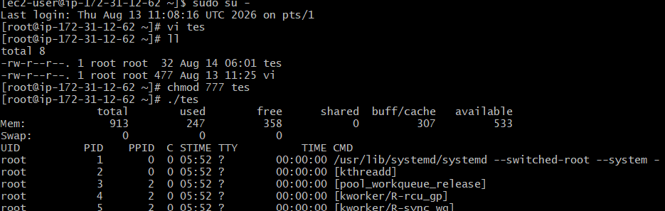
- Check the current shell : echo $0
- Check available shells : cat /etc/shells
Purpose: Displays the shells available on the Linux system.
Example:
/bin/sh
/bin/bash
/usr/bin/sh
/usr/bin/bash
/bin/csh
/bin/tcsh
3. Check Linux users : cat /etc/passwd

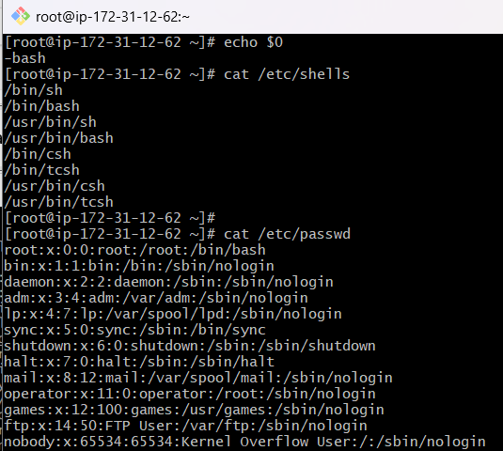
- If we want to switch to other shell then executes sh and do echo $0 same for other shells as well.
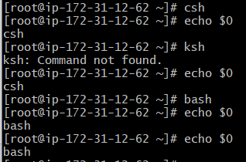
- How to Run a Script
A script can be executed using an absolute path or a relative path.
1. Absolute Path
An absolute path starts from the root directory / and gives the complete location of the script.
/ → Root
/home → Home directory
/ec2-user → User directory
/test.sh → Script
Absolute path = complete path from /
- A relative path starts from your current directory.
First check where you are: pwd
Run test.sh from the current directory.

Important Difference
Type | Example | Meaning
Absolute path | /home/ec2-user/test.sh | Complete path from /
Relative path | ./test.sh | From current directory

Basic Shell Scripts:
Output to screen
#!/bin/bash
# Simple output script
echo "Hello World"

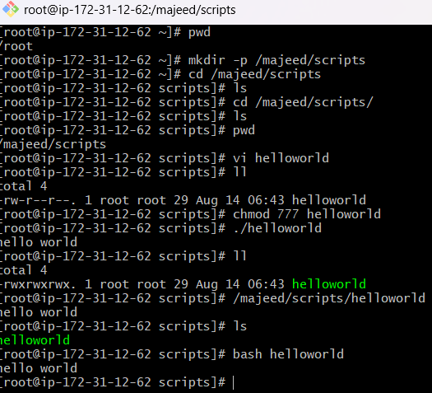

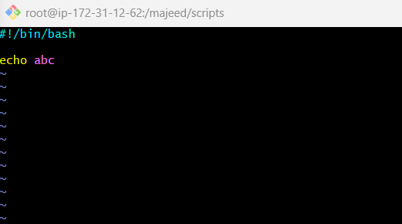
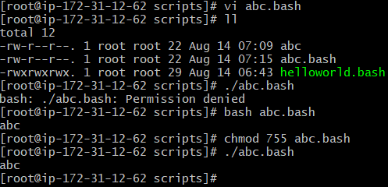
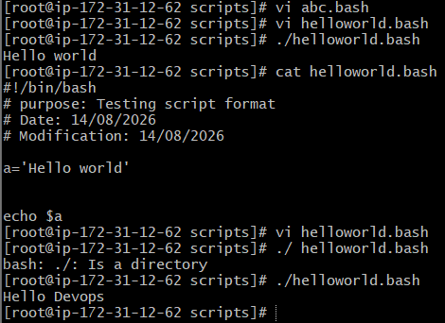

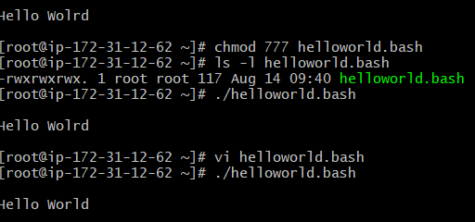

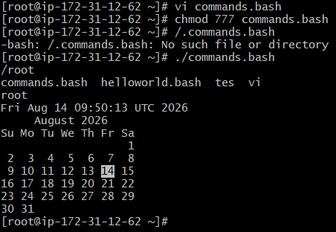
Defining Tasks: I created a shell script that perfoirm multiple small linux tasks such as pwd,ls,whoami,date,cal anf file creation
#!/bin/bash
# Define small tasks
whoami
pwd
date
ls
touch a b c

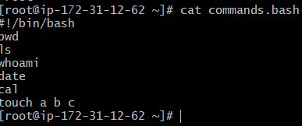
Top command is used to monitoring system performance

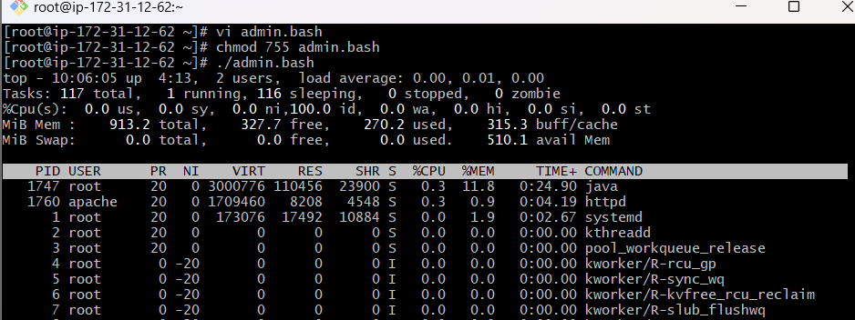
Edit to top 10: top | head -10: display top lines of system monitoring output -top, df -h, free -h,
Iostat.
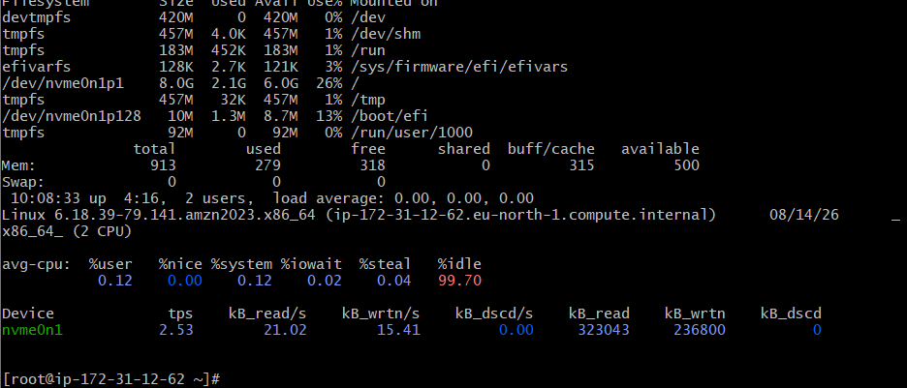

Define Variables: A variable is used to store a value or command in a shell script so it can used later.

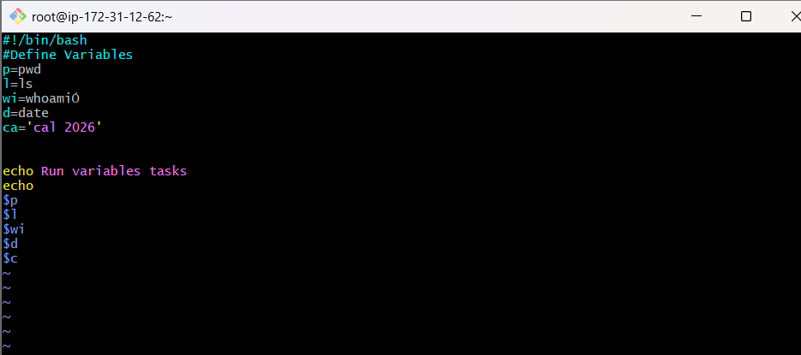
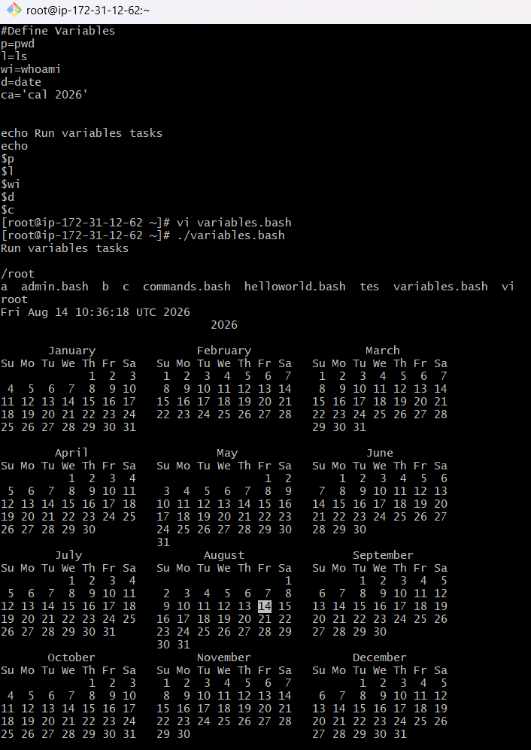

- Input and Output Script: A shell script that takes input from the user, processes it, and displays the output.

